* **Section : Skills**

Managing Bootstrap container for all the responsive breakpoints and accessing the icons.

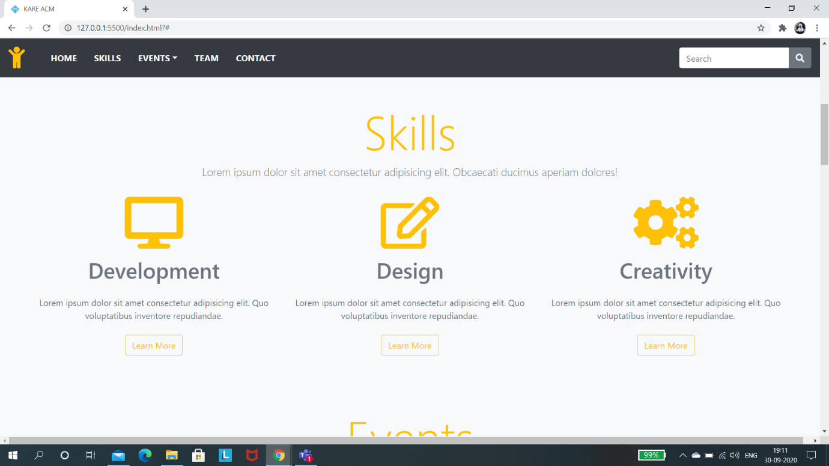

* **Section : Events**

Inserting images in rows upto columns width arrangement for all the projects.

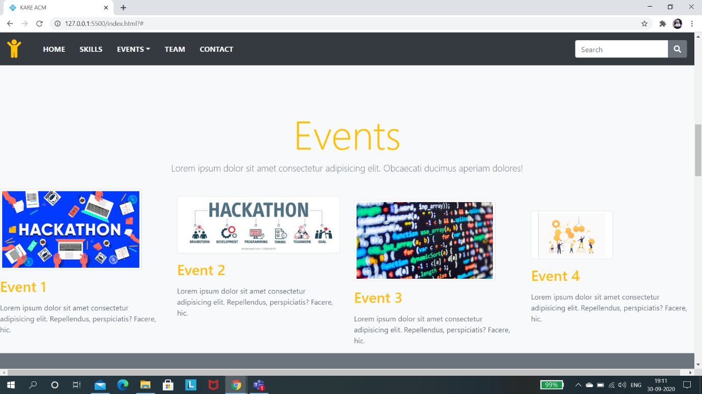

* **Section : Team**

Organizing Bootstrap cards and Its properties like card-title, card-subtitle, card-mg, card body,etc,.

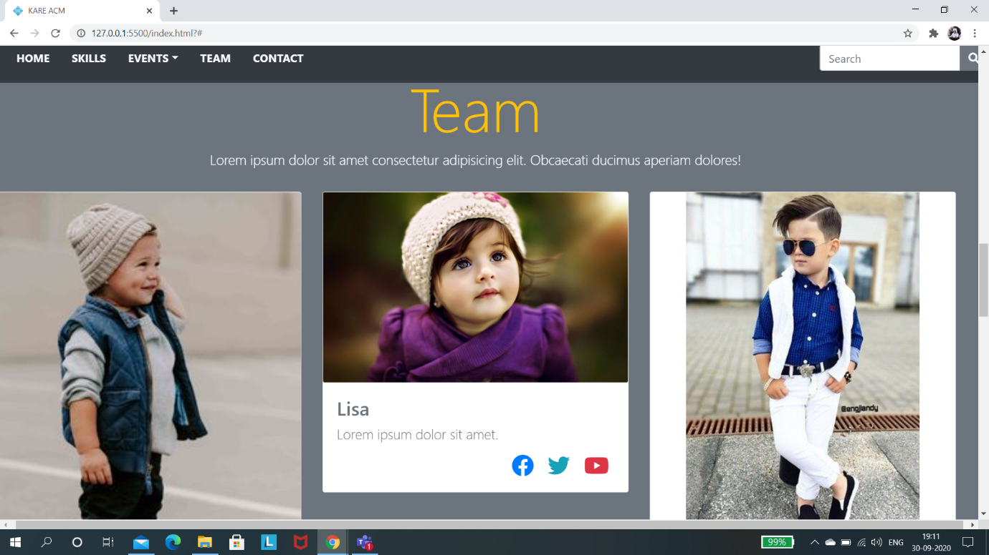

* **Section : Progress**

Managing bootstrap progress bars and their widths.

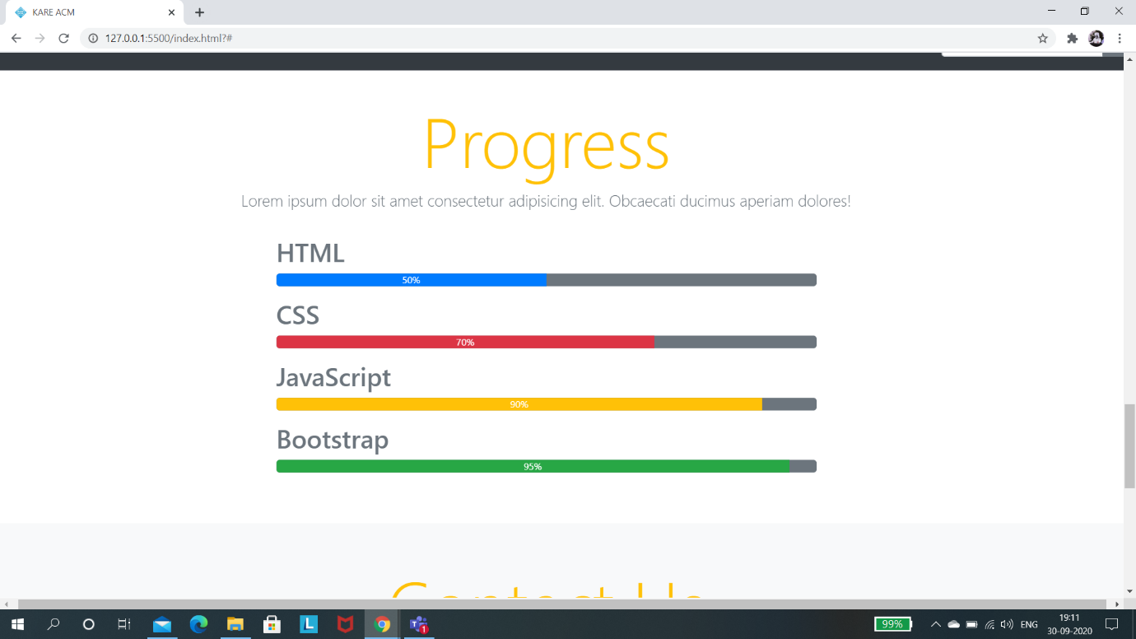

* **Section : Contact**

Working with bootstrap form class and its sub classes like form-inline, form-group , etc,. And also the Input tag properties like text, email, textarea, etc,.

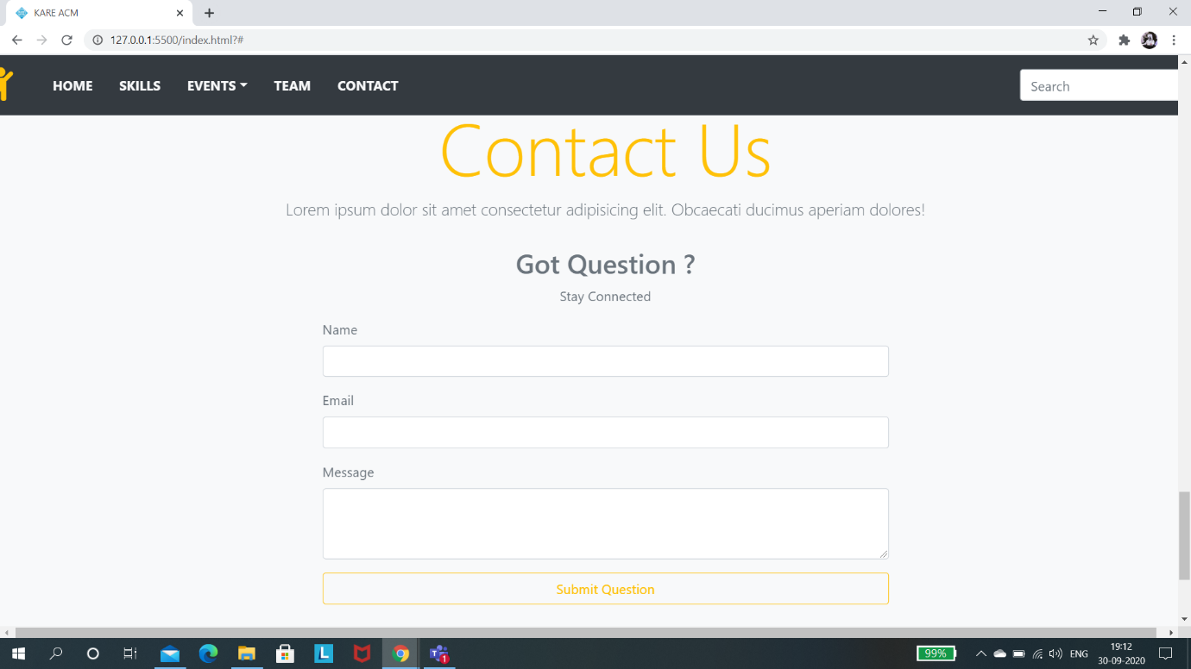

* **Section : Footer**

Creating Footer Title and Creating Social media labels of org and displaying the copyrights of org, etc,.

